https://roadmap.alexhyett.com/backend-developer-roadmap/

https://www.youtube.com/watch?v=bDWApqAUjEI

https://www.alexhyett.com/hexagonal-architecture/

Alister Cockburn, who came up with the idea for hexagonal architecture realized that there really wasn’t much difference between interacting with a database compared to other external applications.
In the same way that we might use an interface and repository to interact with a database. We can use ports and adapters for all of our inputs and outputs to our application.
At the heart, we have the core logic of our application. The goal here is to create abstractions between the inputs and outputs of the application.

- It is preferred when we communicate with multiple apps
- In hexagonagonal we have two side input side(driven and driving)
- It focuses on abstraction and loose coupling

Ports #
For each input and output to the application, we have a port. This is simply an abstraction.
Say we want to read and write from a database, instead of calling the database in our application, we might have a generic read and save method that gets called.
The application doesn’t care whether we are saving to a database, a file system or an event-based queue. All it needs to know is that there is a way to read and write data.
Just as a USB port allows multiple types of devices to communicate with a computer as long as they have a USB adapter.

Adapters #
All the code for actually communicating with the database happens inside the adapter.
This way the application does not need to understand anything about the underlying technologies being used all this is done inside the adapter.
If you have ever written a repository for a database then you will probably be familiar with the concept.

Application
The Application is the core of the system, it contains the Application Services which orchestrate the functionality or the use cases. It also contains the Domain Model, which is the business logic embedded in Aggregates, Entities, and Value Objects.
When paired with Domain-Driven Design, the Application, or Hexagon, contains both the Application and the Domain layers, leaving the User Interface and Infrastructure layers outside.

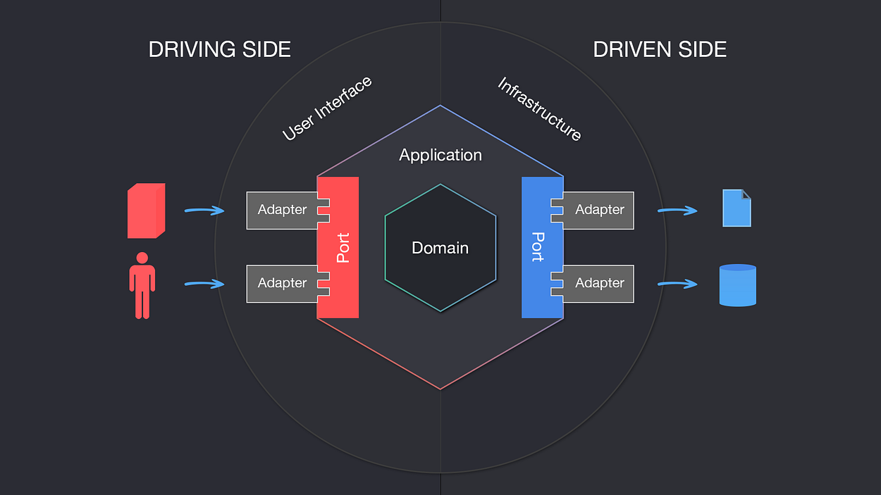

The input is driving our application to do something and the outputs are driven by the application itself.
Ports has interfaces for both the sides, but the implementation varies
For driving side the Implementation is done by Application Services and on the driven side implementation is done by Adapter

On the Driving side, the Adapter depends on the Port, which is implemented by the Application Service,
On the Driven side, the Application Service is the one that depends on the Port, and the Adapter is the one that implements the Port’s Interface,
The high-level modules are generally the core business logic of an application whereas the low-level modules are input/output, database, file system, web API, or other external modules that interact with users, hardware, or other systems.

Why is it called Hexagonal Architecture? #
The hexagon is just a shape to help visualise the architecture and doesn’t really have any real-world reasoning behind it.
Except, what do you think of when you see a hexagon?
For me, I think of a honeycomb with lots of hexagons connected together.
Your application can have multiple inputs and ports and one of those might be an API. When we save data we generally think of saving it to a database or a filesystem.
However, if you have ever worked with cloud platforms such as AWS, you will know that when you save to DynamoDB, you will be using an AWS API.
So if the inputs of your application are an API and your output might also be calling an API then you can start to imagine how each of these applications might link together like a big honeycomb.
If you have a particularly large application you can start splitting it up into different domains. This is the concept behind domain-driven design where each application is only responsible for one domain.

For Pros and Cons: https://www.alexhyett.com/hexagonal-architecture/
The Ports and Adapters architecture also plays along very well with Domain-Driven Design, the main advantage it brings is that it shields domain logic to leak out of your application’s core. Just be vigilant of leakage between Application and Domain layers.

Driving Side vs Driven Side
https://medium.com/ssense-tech/hexagonal-architecture-there-are-always-two-sides-to-every-story-bc0780ed7d9c

Domain-Driven Design (DDD)
https://www.geeksforgeeks.org/domain-driven-design-ddd/

Doubt:
Hexagonal architecture is great for large applications that have a lot of different inputs and outputs but if you are working on a small application, it is probably not worth adding in all the additional complexity.

When should we use this??

